DBMS Concurrency Control
Concurrency Control is the management procedure that is required for controlling concurrent execution of the operations that take place on a database.
But before knowing about concurrency control, we should know about concurrent execution.

Concurrent Execution in DBMS
- In a multi-user system, multiple users can access and use the same database at one time, which is known as the concurrent execution of the database. It means that the same database is executed simultaneously on a multi-user system by different users.
- While working on the database transactions, there occurs the requirement of using the database by multiple users for performing different operations, and in that case, concurrent execution of the database is performed.
- The thing is that the simultaneous execution that is performed should be done in an interleaved manner, and no operation should affect the other executing operations, thus maintaining the consistency of the database. Thus, on making the concurrent execution of the transaction operations, there occur several challenging problems that need to be solved.

Problems with Concurrent Execution
In a database transaction, the two main operations are READ and WRITE operations. So, there is a need to manage these two operations in the concurrent execution of the transactions as if these operations are not performed in an interleaved manner, and the data may become inconsistent. So, the following problems occur with the Concurrent Execution of the operations:
Problem 1: Lost Update Problems (W - W Conflict)
The problem occurs when two different database transactions perform the read/write operations on the same database items in an interleaved manner (i.e., concurrent execution) that makes the values of the items incorrect hence making the database inconsistent.
For example:
Consider the below diagram where two transactions TX and TY, are performed on the same account A where the balance of account A is $300.
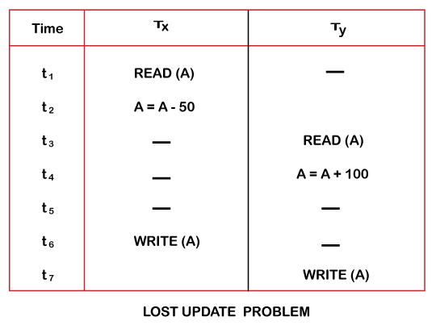
- At time t1, transaction TX reads the value of account A, i.e., $300 (only read).
- At time t2, transaction TX deducts $50 from account A that becomes $250 (only deducted and not updated/write).
- Alternately, at time t3, transaction TY reads the value of account A that will be $300 only because TX didn't update the value yet.
- At time t4, transaction TY adds $100 to account A that becomes $400 (only added but not updated/write).
- At time t6, transaction TX writes the value of account A that will be updated as $250 only, as TY didn't update the value yet.
- Similarly, at time t7, transaction TY writes the values of account A, so it will write as done at time t4 that will be $400. It means the value written by TX is lost, i.e., $250 is lost.
Hence data becomes incorrect, and database sets to inconsistent.

Dirty Read Problems (W-R Conflict)
The dirty read problem occurs when one transaction updates an item of the database, and somehow the transaction fails, and before the data gets rollback, the updated database item is accessed by another transaction. There comes the Read-Write Conflict between both transactions.
For example:
Consider two transactions TX and TY in the below diagram performing read/write operations on account A where the available balance in account A is $300:
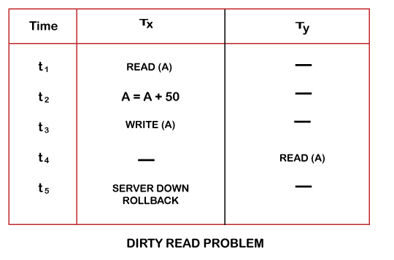
- At time t1, transaction TX reads the value of account A, i.e., $300.
- At time t2, transaction TX adds $50 to account A that becomes $350.
- At time t3, transaction TX writes the updated value in account A, i.e., $350.
- Then at time t4, transaction TY reads account A that will be read as $350.
- Then at time t5, transaction TX rollbacks due to server problem, and the value changes back to $300 (as initially).
- But the value for account A remains $350 for transaction TY as committed, which is the dirty read and therefore known as the Dirty Read Problem.

Unrepeatable Read Problem (W-R Conflict)
Also known as Inconsistent Retrievals Problem that occurs when in a transaction, two different values are read for the same database item.
For example:
Consider two transactions, TX and TY, performing the read/write operations on account A, having an available balance = $300. The diagram is shown below:
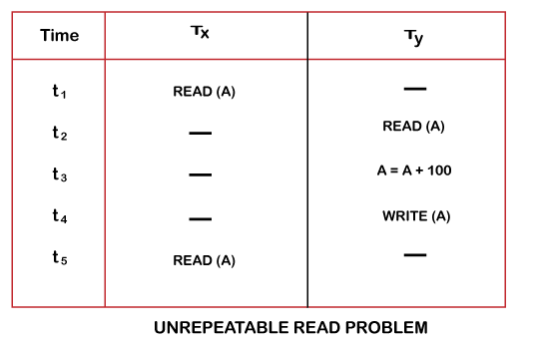
- At time t1, transaction TX reads the value from account A, i.e., $300.
- At time t2, transaction TY reads the value from account A, i.e., $300.
- At time t3, transaction TY updates the value of account A by adding $100 to the available balance, and then it becomes $400.
- At time t4, transaction TY writes the updated value, i.e., $400.
- After that, at time t5, transaction TX reads the available value of account A, and that will be read as $400.
- It means that within the same transaction TX, it reads two different values of account A, i.e., $ 300 initially, and after updation made by transaction TY, it reads $400. It is an unrepeatable read and is therefore known as the Unrepeatable read problem.
Thus, in order to maintain consistency in the database and avoid such problems that take place in concurrent execution, management is needed, and that is where the concept of Concurrency Control comes into role.

Concurrency Control
Concurrency Control is the working concept that is required for controlling and managing the concurrent execution of database operations and thus avoiding the inconsistencies in the database. Thus, for maintaining the concurrency of the database, we have the concurrency control protocols.

Concurrency Control Protocols
The concurrency control protocols ensure the atomicity, consistency, isolation, durability and serializability of the concurrent execution of the database transactions. Therefore, these protocols are categorized as:
- Lock Based Concurrency Control Protocol
- Time Stamp Concurrency Control Protocol
- Validation Based Concurrency Control Protocol

Different categories of protocols:
- Lock Based Protocol
  - Basic 2-PL
  - Conservative 2-PL
  - Strict 2-PL
  - Rigorous 2-PL
- Graph Based Protocol
- Time-Stamp Ordering Protocol
- Multiple Granularity Protocol
- Multi-version Protocol

Lock-Based Protocol
In this type of protocol, any transaction cannot read or write data until it acquires an appropriate lock on it. There are two types of lock:
Lock Based Protocols –
A lock is a variable associated with a data item that describes a status of data item with respect to possible operation that can be applied to it. They synchronize the access by concurrent transactions to the database items. It is required in this protocol that all the data items must be accessed in a mutually exclusive manner. Let me introduce you to two common locks which are used and some terminology followed in this protocol.
- Shared Lock (S): also known as Read-only lock. As the name suggests it can be shared between transactions because while holding this lock the transaction does not have the permission to update data on the data item. S-lock is requested using lock-S instruction.
- Exclusive Lock (X): Data item can be both read as well as written.This is Exclusive and cannot be held simultaneously on the same data item. X-lock is requested using lock-X instruction.
Lock Compatibility Matrix –
- A transaction may be granted a lock on an item if the requested lock is compatible with locks already held on the item by other
transactions.
- Any number of transactions can hold shared locks on an item, but if any transaction holds an exclusive(X) on the item no other transaction may hold any lock on the item.
- If a lock cannot be granted, the requesting transaction is made to wait till all incompatible locks held by other transactions have been released. Then the lock is granted.
Upgrade / Downgrade locks : A transaction that holds a lock on an item A is allowed under certain condition to change the lock state from one state to another.
Upgrade: A S(A) can be upgraded to X(A) if Ti is the only transaction holding the S-lock on element A.
Downgrade: We may downgrade X(A) to S(A) when we feel that we no longer want to write on data-item A. As we were holding X-lock on A, we need not check any conditions.
So, by now we are introduced with the types of locks and how to apply them. But wait, just by applying locks if our problems could’ve been avoided then life would’ve been so simple! If you have done Process Synchronization under OS you must be familiar with one consistent problem, starvation and Deadlock! We’ll be discussing them shortly, but just so you know we have to apply Locks but they must follow a set of protocols to avoid such undesirable problems. Shortly we’ll use 2-Phase Locking (2-PL) which will use the concept of Locks to avoid deadlock. So, applying simple locking, we may not always produce Serializable results, it may lead to Deadlock Inconsistency.

Problem With Simple Locking…
Consider the Partial Schedule:
 | T1 | T2
1 | lock-X(B)
2 | read(B)
3 | B:=B-50
4 | write(B)
5 |  | lock-S(A)
6 |  | read(A)
7 |  | lock-S(B)
8 | lock-X(A)
9 | …… | ……
Deadlock – consider the above execution phase. Now, T1 holds an Exclusive lock over B, and T2 holds a Shared lock over A. Consider Statement 7, T2 requests for lock on B, while in Statement 8 T1 requests lock on A. This as you may notice imposes a Deadlock as none can proceed with their execution.
Starvation – is also possible if concurrency control manager is badly designed. For example: A transaction may be waiting for an X-lock on an item, while a sequence of other transactions request and are granted an S-lock on the same item. This may be avoided if the concurrency control manager is properly designed.

1. Shared lock:
- It is also known as a Read-only lock. In a shared lock, the data item can only read by the transaction.
- It can be shared between the transactions because when the transaction holds a lock, then it can't update the data on the data item.
2. Exclusive lock:
In the exclusive lock, the data item can be both reads as well as written by the transaction.
- This lock is exclusive, and in this lock, multiple transactions do not modify the same data simultaneously.

There are four types of lock protocols available:

1. Simplistic lock protocol
It is the simplest way of locking the data while transaction. Simplistic lock-based protocols allow all the transactions to get the lock on the data before insert or delete or update on it. It will unlock the data item after completing the transaction.

2. Pre-claiming Lock Protocol
- Pre-claiming Lock Protocols evaluate the transaction to list all the data items on which they need locks.
- Before initiating an execution of the transaction, it requests DBMS for all the lock on all those data items.
- If all the locks are granted then this protocol allows the transaction to begin. When the transaction is completed then it releases all the lock.
- If all the locks are not granted then this protocol allows the transaction to rolls back and waits until all the locks are granted.
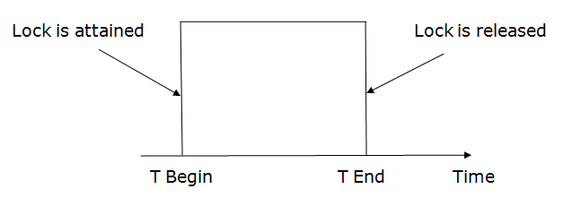

3. Two-phase locking (2PL)
- The two-phase locking protocol divides the execution phase of the transaction into three parts.
- In the first part, when the execution of the transaction starts, it seeks permission for the lock it requires.
- In the second part, the transaction acquires all the locks. The third phase is started as soon as the transaction releases its first lock.
- In the third phase, the transaction cannot demand any new locks. It only releases the acquired locks.
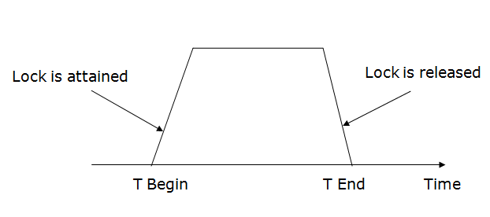
There are two phases of 2PL:
Growing phase: In the growing phase, a new lock on the data item may be acquired by the transaction, but none can be released.
Shrinking phase: In the shrinking phase, existing lock held by the transaction may be released, but no new locks can be acquired.
In the below example, if lock conversion is allowed then the following phase can happen:
- Upgrading of lock (from S(a) to X (a)) is allowed in growing phase.
- Downgrading of lock (from X(a) to S(a)) must be done in shrinking phase.
Example:
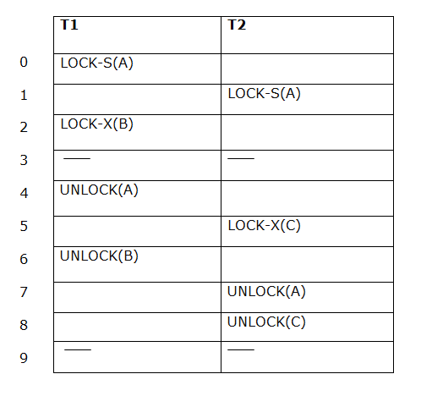
The following way shows how unlocking and locking work with 2-PL.
Transaction T1:
- Growing phase: from step 1-3
- Shrinking phase: from step 5-7
- Lock point: at 3
Transaction T2:
- Growing phase: from step 2-6
- Shrinking phase: from step 8-9
- Lock point: at 6

4. Strict Two-phase locking (Strict-2PL)
- The first phase of Strict-2PL is similar to 2PL. In the first phase, after acquiring all the locks, the transaction continues to execute normally.
- The only difference between 2PL and strict 2PL is that Strict-2PL does not release a lock after using it.
- Strict-2PL waits until the whole transaction to commit, and then it releases all the locks at a time.
- Strict-2PL protocol does not have shrinking phase of lock release.
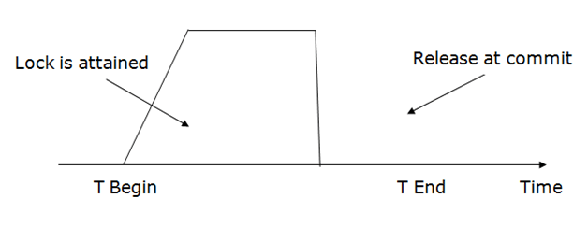
It does not have cascading abort as 2PL does.
 | Simle lock | 2 PL LOCK | Strict 2 PL | Conservative 2PL | Rigorous 2PL
serializability | Does not gurantee of serializable | - serializable | serializable
Deadlock |  | - YES | YES
recoverable
cascadeless/cascade
Starvation |  | - YES
Advantages

Two Phase Locking –
A transaction is said to follow Two Phase Locking protocol if Locking and Unlocking can be done in two phases.
- Growing Phase: New locks on data items may be acquired but none can be released.
- Shrinking Phase: Existing locks may be released but no new locks can be acquired.
Note –If lock conversion is allowed, then upgrading of lock( from S(a) to X(a) ) is allowed in Growing Phase and downgrading of lock (from X(a) to S(a)) must be done in shrinking phase.
Let’s see a transaction implementing 2-PL.
 | T1 | T2
1 | lock-S(A)
2 |  | lock-S(A)
3 | lock-X(B)
4 | ……. | ……
5 | Unlock(A)
6 |  | Lock-X(C)
7 | Unlock(B)
8 |  | Unlock(A)
9 |  | Unlock(C)
10 | ……. | ……
This is just a skeleton transaction which shows how unlocking and locking works with 2-PL. Note for:
Transaction T1:
- Growing Phase is from steps 1-3.
- Shrinking Phase is from steps 5-7.
- Lock Point at 3
Transaction T2:
- Growing Phase is from steps 2-6.
- Shrinking Phase is from steps 8-9.
- Lock Point at 6
Hey, wait!
What is LOCK POINT ?The Point at which the growing phase ends, i.e., when transaction takes the final lock it needs to carry on its work. Now look at the schedule, you’ll surely understand.
I have said that 2-PL ensures serializablity, but there are still some drawbacks of 2-PL. Let’s glance at the drawbacks:
- Cascading Rollback is possible under 2-PL.
- Deadlocks and Starvation is possible.

Strict 2-PL –
This requires that in addition to the lock being 2-Phase all Exclusive(X) Locks held by the transaction be released until after the Transaction Commits.
Following Strict 2-PL ensures that our schedule is:
- Recoverable
- Cascadeless
Hence it gives us freedom from Cascading Abort which was still there in Basic 2-PL and moreover guarantee Strict Schedules but still Deadlocks are possible!

Rigorous 2-PL –
This requires that in addition to the lock being 2-Phase all Exclusive(X) and Shared(S) Locks held by the transaction be released until after the Transaction Commits.
Following Rigorous 2-PL ensures that our schedule is:

- Recoverable
- Cascadeless
Hence it gives us freedom from Cascading Abort which was still there in Basic 2-PL and moreover guarantee Strict Schedules but still Deadlocks are possible!
Note the difference between Strict 2-PL and Rigorous 2-PL is that Rigorous is more restrictive, it requires both Exclusive and Shared locks to be held until after the Transaction commits and this is what makes the implementation of Rigorous 2-PL more easy.

Conservative 2-PL –
A.K.A Static 2-PL, this protocol requires the transaction to lock all the items it access before the Transaction begins execution by predeclaring its read-set and write-set. If any of the predeclared items needed cannot be locked, the transaction does not lock any of the items, instead it waits until all the items are available for locking.
Conservative 2-PL is Deadlock free and but it does not ensure Strict schedule(More about this here!). However, it is difficult to use in practice because of need to predeclare the read-set and the write-set which is not possible in many situations. In practice, the most popular variation of 2-PL is Strict 2-PL.
The Venn Diagram below shows the classification of schedules which are rigorous and strict. The universe represents the schedules which can be serialized as 2-PL. Now as the diagram suggests, and it can also be logically concluded, if a schedule is Rigorous then it is Strict. We can also think in another way, say we put a restriction on a schedule which makes it strict, adding another to the list of restrictions make it Rigorous. Take a moment to again analyze the diagram and you’ll definitely get it.
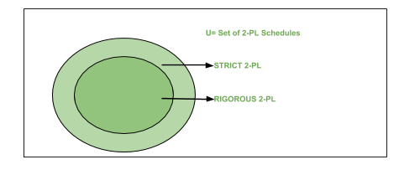
Image – Venn Diagram showing categories of languages under 2-PL
Now, let’s see the schedule below, tell me if this schedule can be locked using 2-PL and if yes, show how and what class of 2-PL does your answer belongs?
 | T1 | T2
1 | Read(A)
2 |  | Read(A)
3 | Read(B)
4 | Write(B)
5 | Commit
6 |  | Read(B)
7 |  | Write(B)
6 |  | Commit
I recommend you to try before looking at the solution.
Yes, the schedule is conflict serializable so we can try implementing 2-PL. So, let’s try….
Solution:
 | T1 | T2
1 | Lock-S(A)
2 | Read(A)
3 |  | Lock-S(A)
4 |  | Read(A)
5 | Lock-X(B)
6 | Read(B)
7 | Write(B)
8 | Commit
9 | Unlock(A)
10 | Unlock(B)
11 |  | Lock-X(B)
12 |  | Read(B)
13 |  | Write(B)
14 |  | Commit
15 |  | Unlock(A)
16 |  | Unlock(B)
Now, this is one way I choose to implement the locks on A and B. You may try a different sequence but remember to follow the 2-PL protocol. With that said, observe that our locks are released after Commit operation so this satisfies Rigorous 2-PL protocol.
By now, I guess you must’ve got the idea how to differentiate between types of 2-PL. Remember the theory as problems come in the examination sometimes just based on theoretical knowledge. Next we’ll look at some examples on Conservative 2-PL and how does it differs from the above two types of 2-PL. What makes it Deadlock free and also so difficult to implement. Then we’ll conclude the topic of 2-PL. Shortly we’ll move on to another type of Lock based Protocols- Graph Based Protocols. They are also very interesting and provides unique method to deal with the problem of Deadlocks! So we’ll learn a new type of locking protocol, that will conclude the topic of Lock based Protocol for GATE, till then Happy Learning.

